

**Sukkur Institute of Business Administration University**

Department of Electrical Engineering

**ESE-211: Digital Logic Design (DLD)**

**Semester Project Fall - 2022**

**Project Name**

**Digital Stop Watch**

Group Members:

1. Tanveer Ahmed

2. Asim Murtaza

Instructor: Dr Safeer Hyder

Certificate

*It is certified that* ***Mr. Tanveer Ahmed*** *having*

*CMSID:* ***O33-20-0030*** *a student of* ***BE-III*** *has carried out the “****Semester Project****” for the subject of* ***Digital Logic Design (DLD)*** *as provided by the Instructor of the subject at the department of Electrical Engineering, Sukkur Institute of Business Administration for* ***Fall-2022.***

Date: _______________ Instructor’s Signature

**Table of Contents**

* **Introduction ------------------------------------------------3**
* **Component list -------------------------------------------- 3**
* **Schematic diagram --------------------------------------- 3**
* **Working principle -----------------------------------------4**
* **Simulation --------------------------------------------------5**
* **Hardware figure--------------------------------------------6**
* **Application -------------------------------------------------7**
* **References --------------------------------------------------8**

**Introduction**

Stop is time measuring devices, which measure time between two intervals for this a stop watch must include a start button and reset button in order to stop the at desired point and restart for again start from initial point.

**Component list**

* **555 timer ic**
* **Common cathode 7-segment display**
* **Resistor (150 ohm, 100k ohm, 56k ohm)**
* **Capacitor (10 uf)**
* **On/off switch**

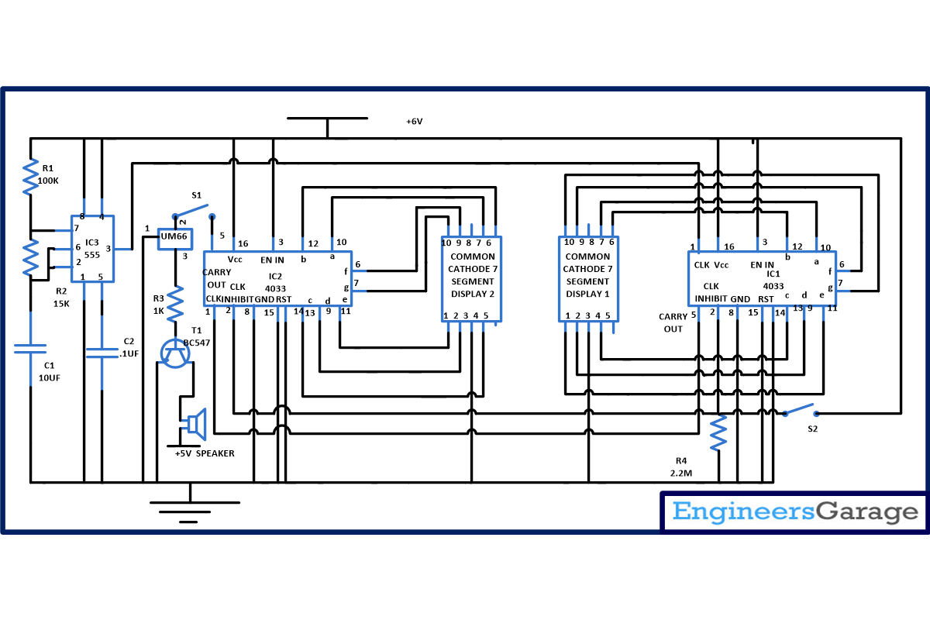**Schematic diagram of the project**

**Working principle of the project**

A stop watch watch circuit basically work like a counter circuit, when we provide power supply it start counting from initial and we can stop it on desired point with help of button

A **digital stopwatch circuit** having two IC namely [**NE555**](http://www.engineersgarage.com/electronic-components/ne555-timer-ic-datasheet) and  **[CD4033](http://www.engineersgarage.com/contribution/anjali/johnson-counter-cd4033)**  and few more component. CD4033 is a **Johnson counter IC** commonly used in digital display. It contain 5 stage Johnson decade counter including decoder which convert the Johnson code to a 7 segment decoded output. Means it will convert the input into numeric display which can be seen on [**7 segment display**](http://www.engineersgarage.com/electronic-components/7-segment-display) which is the basic work of decoder.

The main working is of start and restart button which differentiate it from counter and make it digital counter.

A key point is to maintain frequency this is controlled by adding resistor and capacitor.

**Simulation**

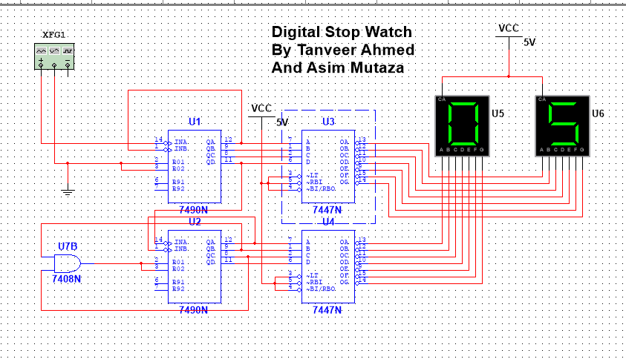

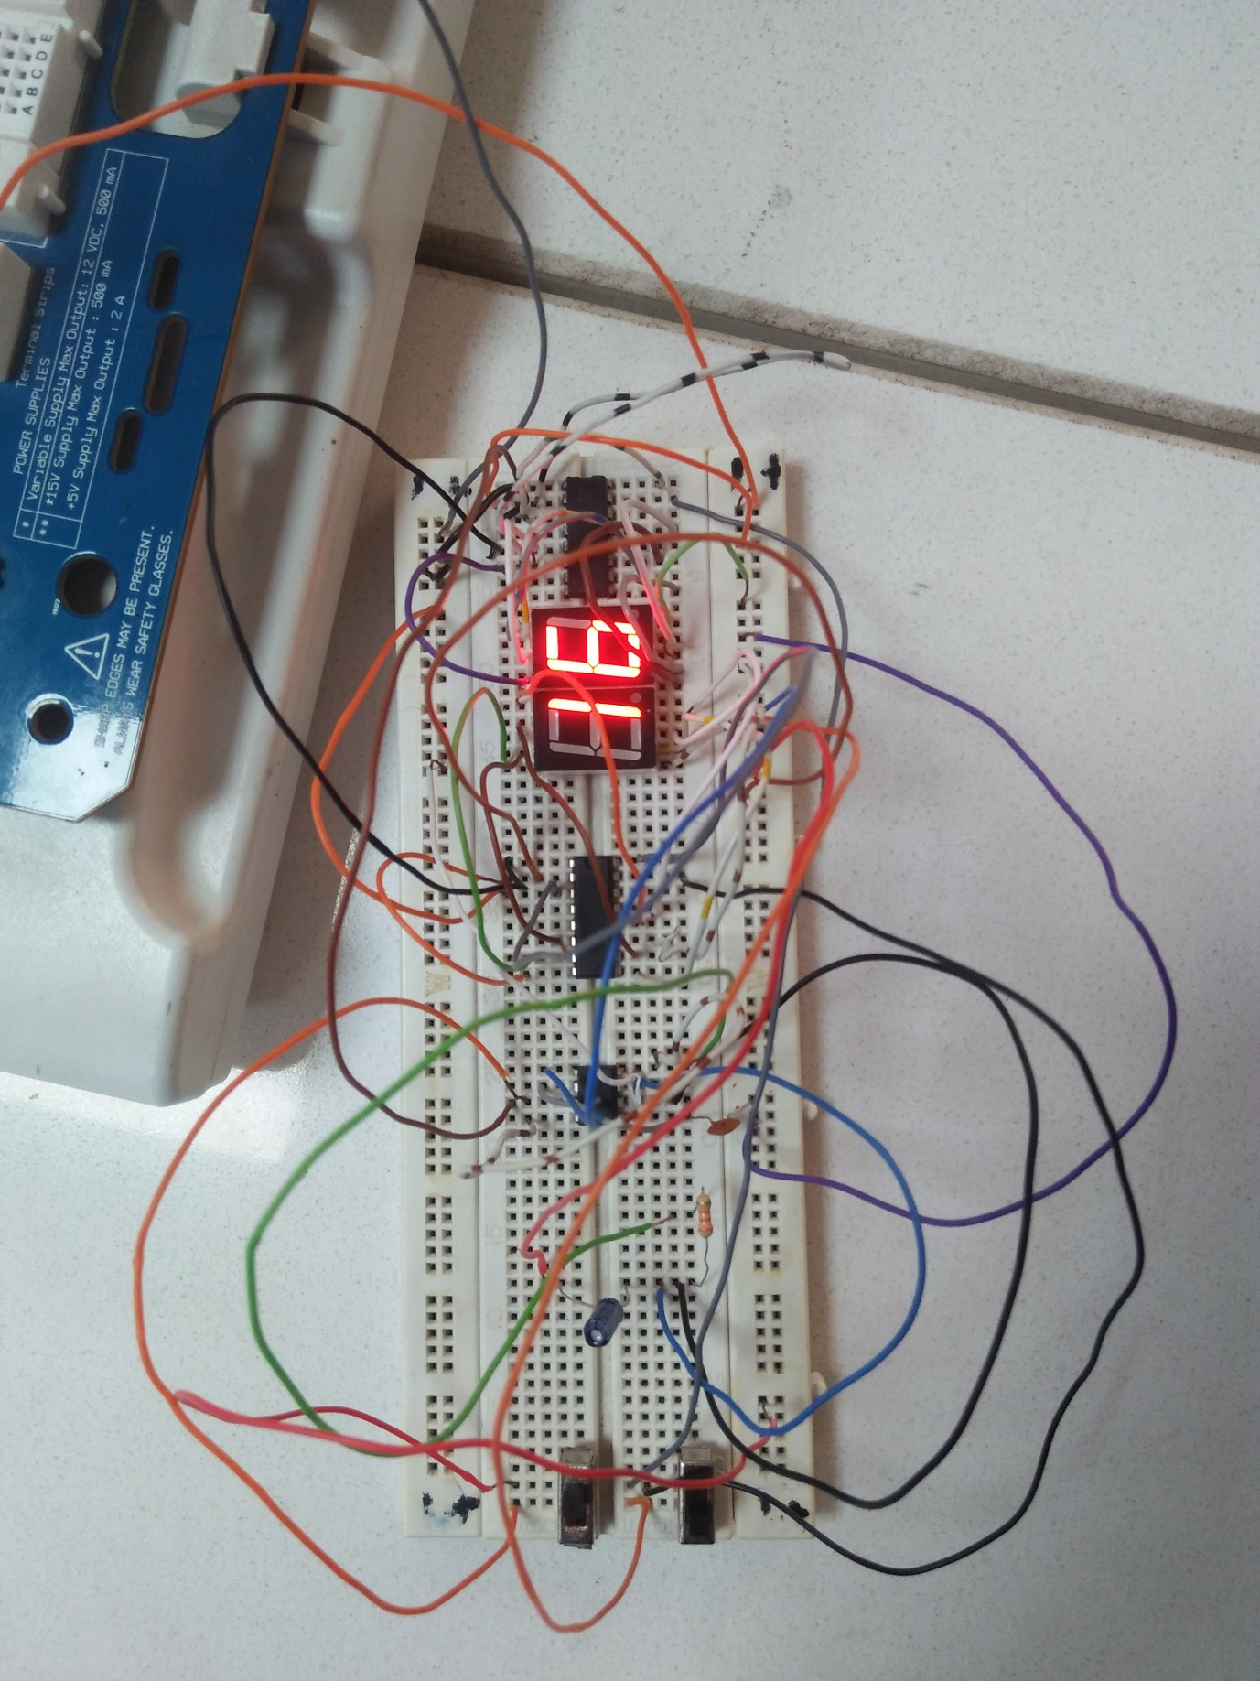**Hardware Figure**

**Applications**

* It uses in cooking
* It uses in gaming
* In competitive exam student use it to make the exam plan
* Sport men use it to maintain their stamina

**References**

Common cathode and anode( from v.k Mehta )

Engineering garage

Decoder seven segment display from (Digital Fundamental by Thomas floyed)